msmtp

📬 What is msmtp?
# Source: AI Source: Provided by: [Data Path: Persons Table -> ID Column: 1, Name_En Column: Motasem Essam] -> From: [ChatGPT] on [1/21/2026]
msmtp is a lightweight SMTP client that sends emails from the command line by forwarding them to an SMTP server — like Gmail, MailHog, or SendGrid.
Think of msmtp as a modern alternative to sendmail, but simpler and easier to configure.

🔍 Key Points:
# Source: AI Source: Provided by: [Data Path: Persons Table -> ID Column: 1, Name_En Column: Motasem Essam] -> From: [ChatGPT] on [1/21/2026]
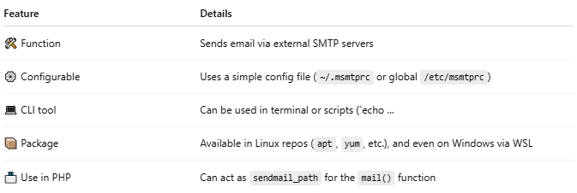

Feature | Details
🛠 Function | Sends email via external SMTP servers
⚙ Configurable | Uses a simple config file (~/.msmtprc or global /etc/msmtprc)
💻 CLI tool | Can be used in terminal or scripts (`echo ...
📦 Package | Available in Linux repos (apt, yum, etc.), and even on Windows via WSL
📨 Use in PHP | Can act as sendmail_path for the mail() function

✅ Example Usage
# Source: AI Source: Provided by: [Data Path: Persons Table -> ID Column: 1, Name_En Column: Motasem Essam] -> From: [ChatGPT] on [1/21/2026]
1. Basic command-line usage:
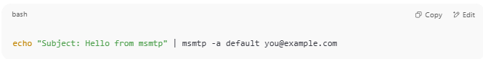
echo "Subject: Hello from msmtp" | msmtp -a default you@example.com

2. Config file: ~/.msmtprc
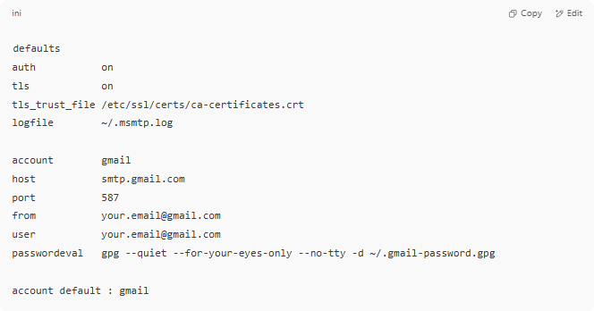
defaults
auth on
tls on
tls_trust_file /etc/ssl/certs/ca-certificates.crt
logfile ~/.msmtp.log

account gmail
host smtp.gmail.com
port 587
from your.email@gmail.com
user your.email@gmail.com
passwordeval gpg --quiet --for-your-eyes-only --no-tty -d ~/.gmail-password.gpg

account default : gmail

Or use password directly (less secure):
password = your_app_password_here

🧪 Common Uses:
# Source: AI Source: Provided by: [Data Path: Persons Table -> ID Column: 1, Name_En Column: Motasem Essam] -> From: [ChatGPT] on [1/21/2026]
- In cron jobs to email logs
- As PHP’s sendmail backend (edit php.ini)
- To test email sending from scripts or Docker containers
- As part of a CI/CD pipeline to notify on deploys/failures

🧰 Set up with PHP
# Source: AI Source: Provided by: [Data Path: Persons Table -> ID Column: 1, Name_En Column: Motasem Essam] -> From: [ChatGPT] on [1/21/2026]
In php.ini:
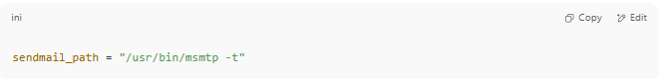
sendmail_path = "/usr/bin/msmtp -t"

Now your mail() calls in PHP will send through msmtp.

✅ Summary
# Source: AI Source: Provided by: [Data Path: Persons Table -> ID Column: 1, Name_En Column: Motasem Essam] -> From: [ChatGPT] on [1/21/2026]
msmtp is:
- Easy to configure
- Great for sending test/dev or even real SMTP email
- Ideal if you want command-line or PHP email sending without a full mail server

